Docufen’s Testing Document
Signatures | Pre-Approval | Post-Approval
PREPARED BY:
Grady Archie
Validation Engineer
REVIEWED BY:
Julia Smith
External Consultant
APPROVED BY:
Julia Smith
Quality Manager
Sign / Name: | Sign:____________  Name: ____________ | Name:____________  Name: ____________

Signature: ____________________________
Date: ________________________
Signature:
Date:
Checkbox | ☐ | ☐
Text | weight (kg): _________________
Attachment image
Attachment video
Attachment PDF

Signature: ____________________________ Date: ________________________
Signature: ____________________________ Date: ________________________

- OQ Test Script

Test Objective: Fringilla phasellus faucibus sceleriue eleifend donec pretium vulputate.

Acceptance Criteria: Et malesuada fames ac turpis egestas maecenas pharetra.

Test Procedure: Odio eu feugiat tium nibh ipsum consequat nisl vel pretium.

Results
Test Description | Result | Acceptance Criteria Met? | Initials / Date
Sterilisation Setpoint temperature = 121ºC |  | Yes ☐  No ☐
Attachment:
Placeholder: | Enter the weight (kg): _________________  Enter the weight (kg): _________________  Enter the weight (kg): _________________
Comments:

Comments:
Checkbox: ☐
Checkbox: ☐
Checkbox: ☐
Comments: _____________

Results Summary
Have all the acceptance criteria been met?  Yes = PASS | No = FAIL | Yes = PASS ☐  No = FAIL ☐
Performed by:
(Sign / Date)

- Attachment Log
No. | Description | No. of Pages | Initials / Date
1
2
3
4
5

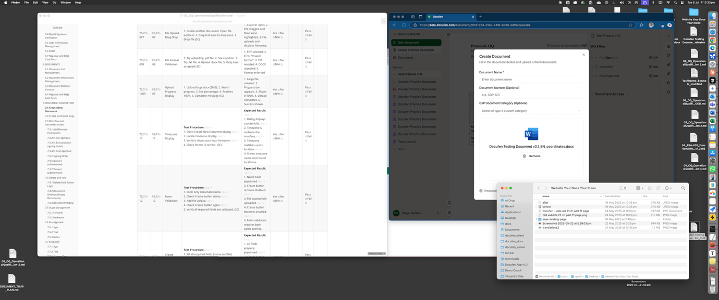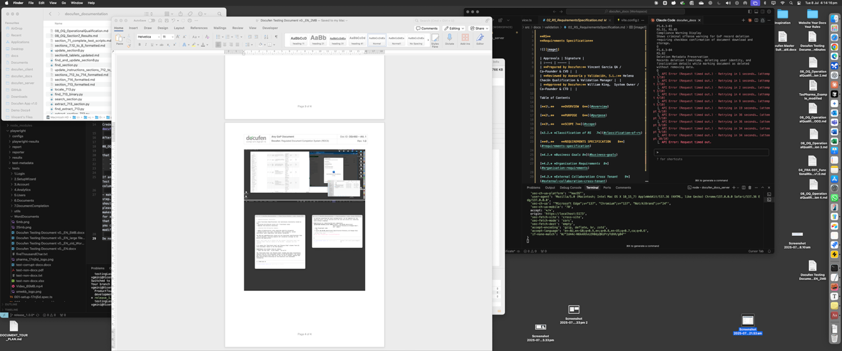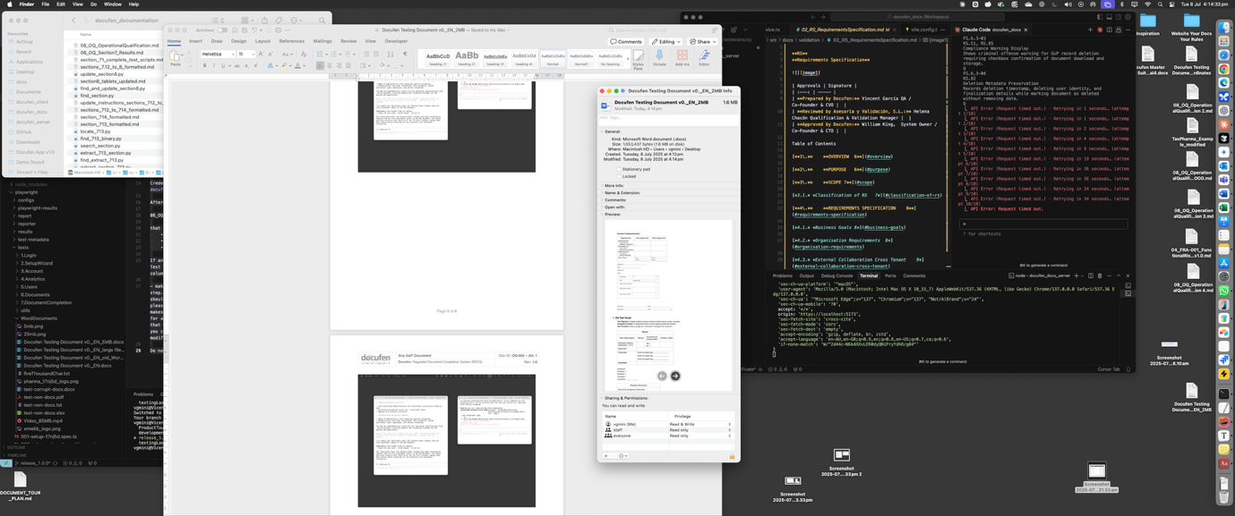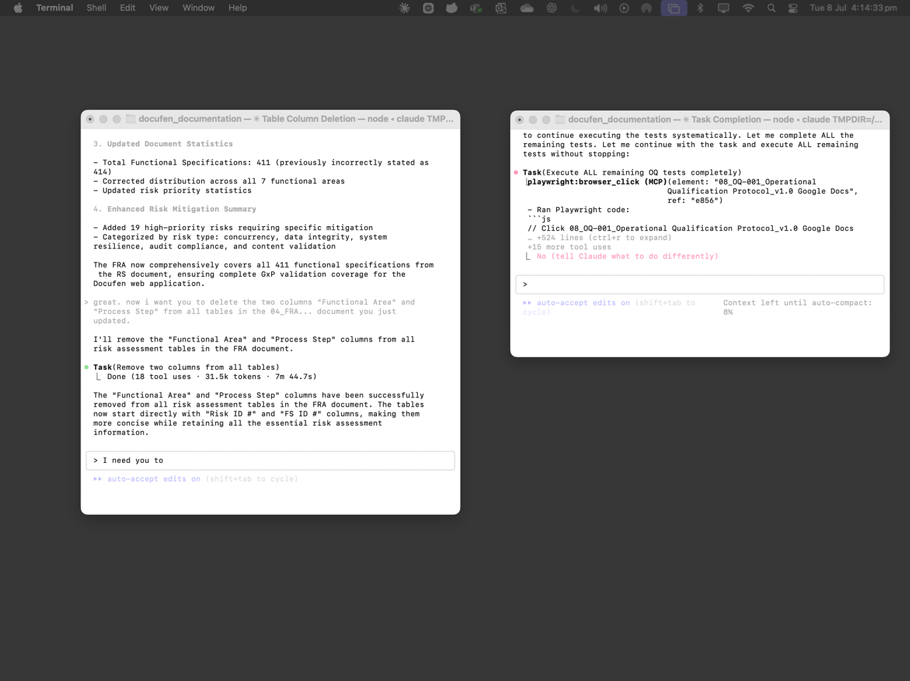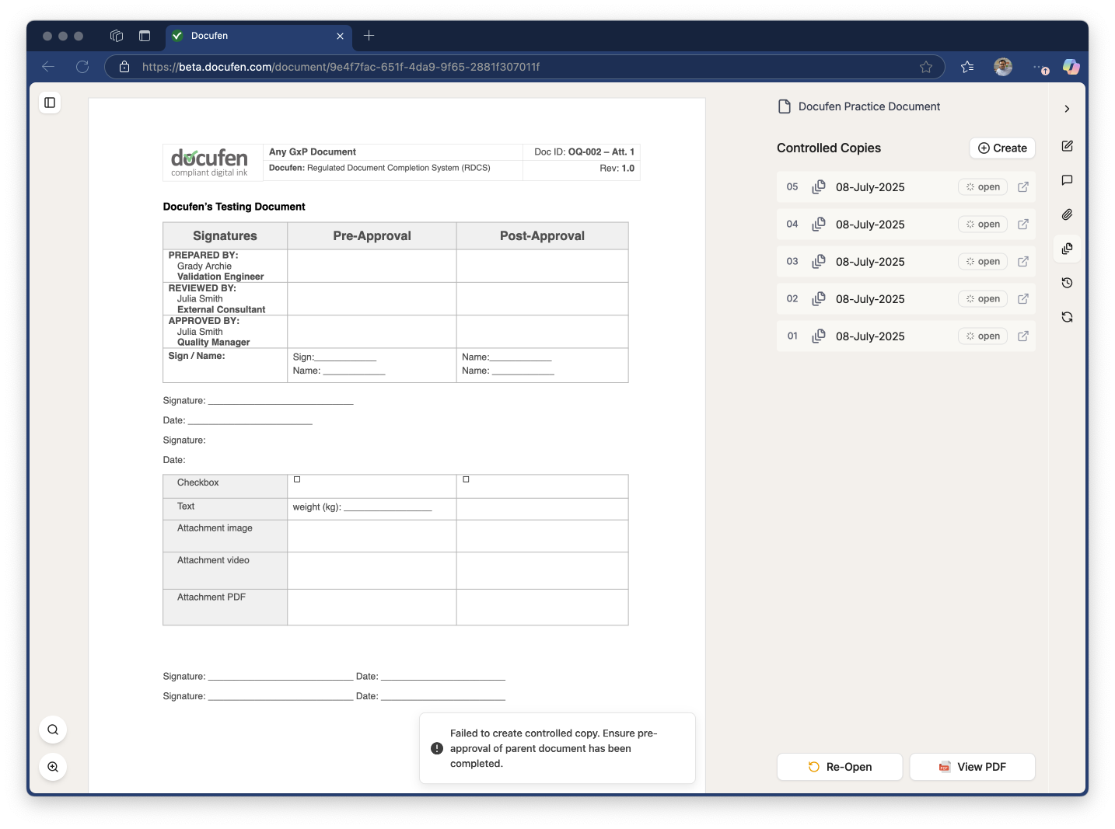

Footer example: Enter the results summary in this section.

